FULL STACK DEVELOPMENT WITH MERN PROJECT DOCUMENTATION

1. Introduction
Project Title : Flight finder -Navigating your Air Travel Option
Team id : LTVIP2025TMID21049Team Members:
- Team Leader:
Akkisetty Mahima Jyothi– Full Stack Developer & Project
Coordinator
Responsible for overall planning, coordination, GitHub management, and integration of frontend and backend.
- Team Member:
Maavuri Santhosh Kumar– Frontend Developer
Works on the React-based UI, handles component design, page routing, and user interactions.
- Team Member:
M.Gowtham Durga Pravin– Backend Developer
Builds RESTful APIs using Node.js and Express.js, manages authentication and server logic.
- Team Member:
M.Durga Charan– Database Administrator
Designs and manages MongoDB schemas, handles CRUD operations and ensures data consistency.

2. Project Overview
- Purpose:
To simplify flight booking and management by providing users with real-time availability, secure bookings, and user-friendly search features.
- Features:
o Search and filter flights o Book tickets with user login o Admin panel for managing flights o Email confirmation and booking history

3. Architecture
- Frontend:
Built with React.js using components, hooks, and React Router for navigation. UI powered by Material-UI.
- Backend:
Developed using Node.js and Express.js. RESTful API handles all CRUD operations related to users, flights, and bookings.
- Database:
MongoDB stores user data, flight details, and booking records. Mongoose is used for schema design and data validation.
- Frontend (React.js) Components: o SearchForm.js: Handles user inputs (source, destination, dates).
o FlightList.js: Displays ranked results from ML model.
State Management: Redux for shared state (user sessions, bookings).
- Backend (Node.js/Express.js) API Routes: javascript
app .get ('/api/flights', flightController .search); app.post('/api/bookings', authMiddleware , bookingController.create); ➢ Middleware: JWT validation, rate limiting. Database (MongoDB) Schemas:
javascript
const User = new Schema({ email: { type: String, unique: true },
bookings: [{ type: Schema.Types.ObjectId, ref: 'Booking' }]
});

4. Setup Instructions
Prerequisites:
- Node.js >= 18
- MongoDB installed and running
- npm or yarn Installation:
o git clone https://github.com/your-username/FlightFinder.git o cd FlightFinder o cd server o npm install o cd ../client o npm install
Environment Variables:
Create a .env file in the /server folder with:
PORT=3000
MONGODB URI-
mongodb+srv://nehapriya:<db_password>@cluster0.zghkpqk.mongodb.net/?retryWrit es=true&w=majority&appName=Cluster0
5. Folder Structure
- Client:
/client
├── /src
│ ├── /components
│ ├── /pages
│ ├── /api
│ ├── App.js │ └── index.js
- Server:
/server
├── /controllers
├── /routes
├── /models
├── server.js
└── .env 5.Running the Application Frontend:
- cd client
- npm start Backend:
- cd server
- npm start

7. API Documentation
- POST /api/auth/register Registers a new user.
Request Body: { name, email, password }
Response: { success, token }
- POST /api/auth/login Logs in an existing user.
- GET /api/flights
Retrieves list of available flights.
- POST /api/bookings
Books a flight for the logged-in user.

8. Authentication
- Implemented using JWT (JSON Web Token).
- Tokens are stored in HTTP-only cookies.
- Protected routes validate tokens before granting access.

9. User Interface
Home Page with flight search
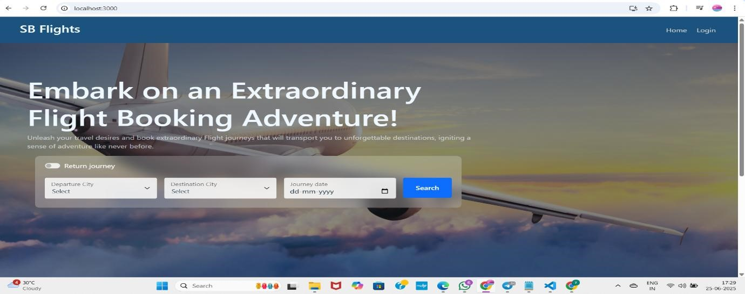
Login form
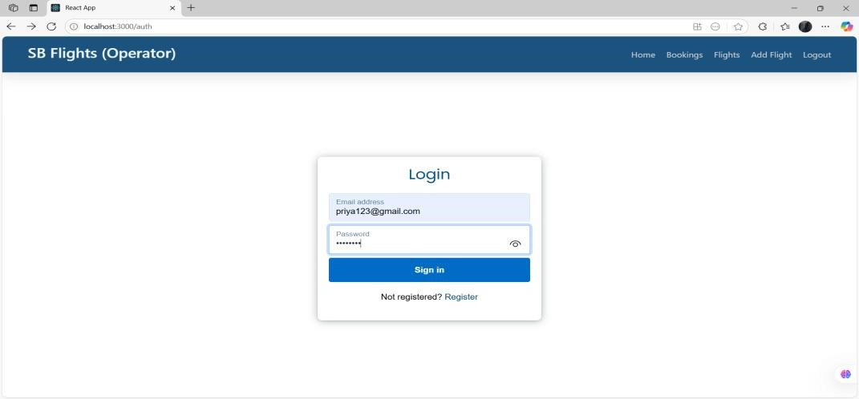
Register form
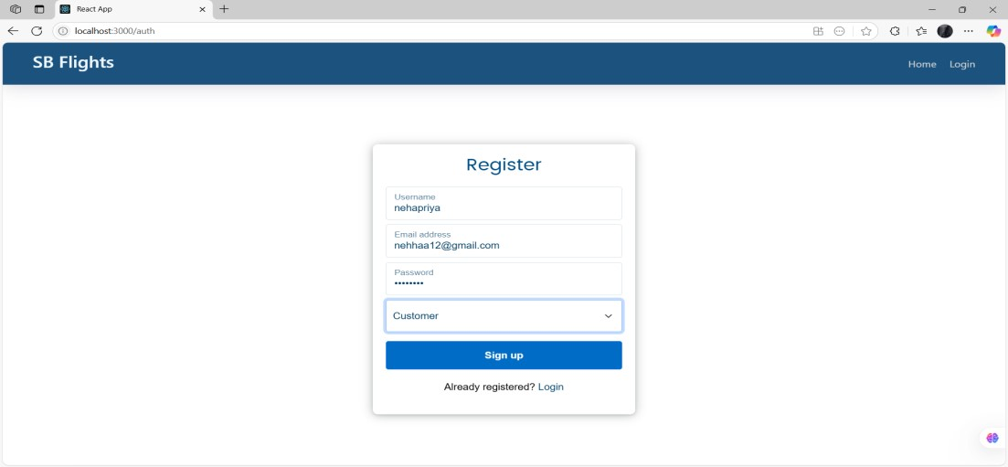
Admin dashboard
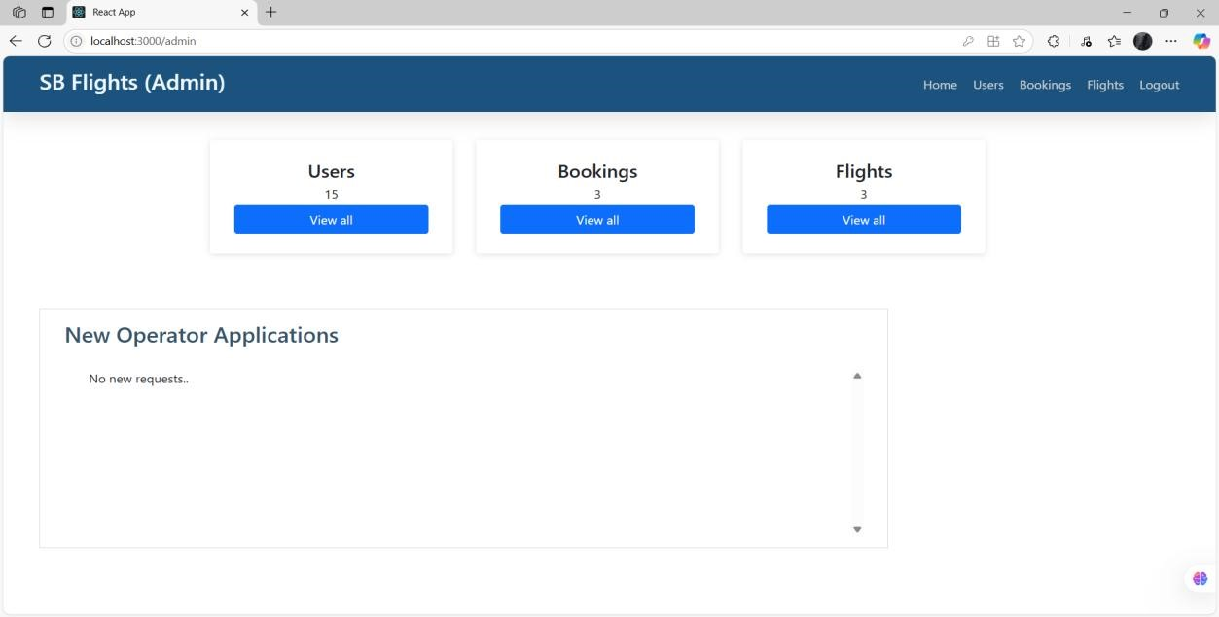
Booking confirmation page
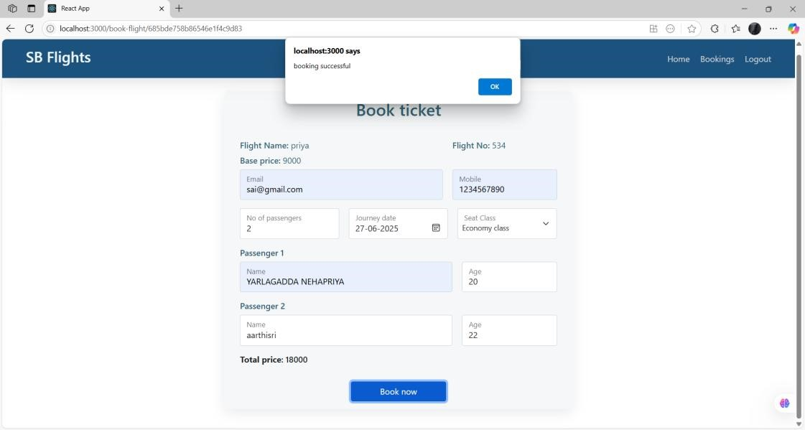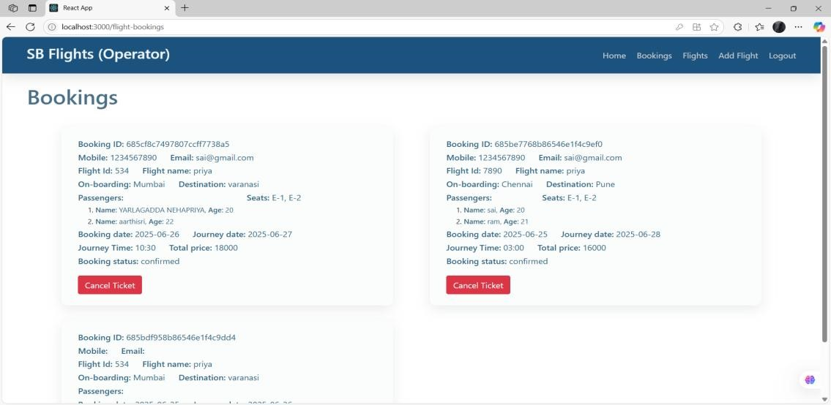

10. Testing
- Manual testing on Postman for backend APIs
- Basic component tests in React using Jest and React Testing Library 11.Demo
Link:
https://drive.google.com/file/d/1pC1eQYezBeBYpmnp9M4fjWzxmS1ZNfF/view?usp=sharing

12. Known Issues
- No password recovery implemented yet
- UI responsiveness needs improvement on tablets

13. Future Enhancements
- Payment integration with Razorpay/Stripe
- Role-based admin access
- Real-time flight tracking integration

